The Trails
Quarter Creek Pavilion –Introduction to The Trails
Our Quarter Creek Pavilion is the perfect starting point for horseback trail riders. Built in 2000, the Pavilion area features covered seating for approximately 40 people, two large accessible grills, a large brick fireplace, and fully accessible bathrooms. The Pavilion’s parking area is horse trailer friendly, offers an outdoor water source for filling water buckets and is close to the 10 miles of horse friendly trails that the park has to offer.

LINK: Trail Map (printer friendly rsion)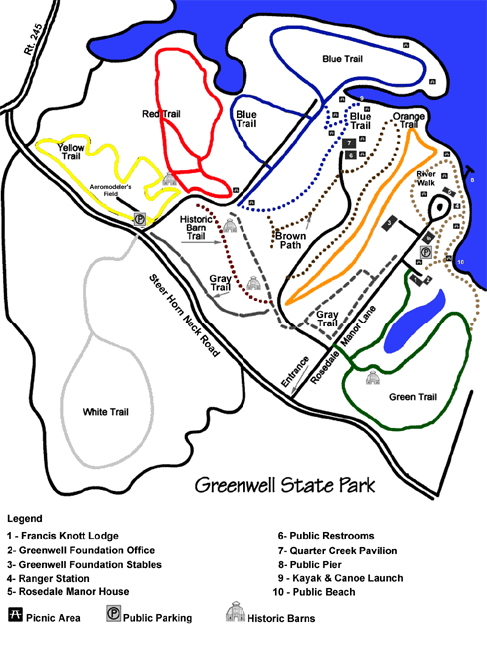
Blue Trail - Difficulty Level: Easy
Passage to the blue trail (1.75 miles) requires use of the Gray Access Trail. The Gray Access is approximately .45 miles through the soy fields. From the Gray Access Trail, the Blue Trail turns right and travels into an open crop field. A grassy path loops around the edge of the field with forest on one side. Through the trees, you may view the Patuxent River. While on the trail, you may see wildlife such as ground hogs, song birds, and white tailed deer. Horses, mountain bikes, and hikers are welcome.
Red Trail - Difficulty Level: Moderate
From the Gray Access Trail (.45 miles), turn to the left for the Red Trail which stretches .73 miles. It travels mainly through deciduous forest. Keep an eye out for a family of gray squirrels hopping through White Oak and Red Maple trees. This trail is suitable for hikers, mountain bikers, and horses.
Yellow Trail - Difficulty Level: Easy
The Yellow Trail (1.15 miles) is accessed by following the Gray Access Trail (.45 miles) and part of the Red Trail. It veers to the left of the Red Trail. While traveling the trail, a grassy field is to your left. This field is home to mice, moles, ground hogs and rabbits. On your right, an inviting forest is filled with raccoons, owls and American Holly trees. Hikers, horses and mountain bikers are permitted.
White Trail - Difficulty Level: Moderate
The White Trail requires passage along the Gray Access Trail (.45 miles), and across Steer Horn Neck Road. This trail is predominantly a hardwood forest. You will find a variety of vegetation such as American Beech, Red Oak, Spice Bush, Mountain Laurel, and many types of grasses. At one point, Cuckold Creek can be viewed from the trail. Hikers, horses and mountain bikers are welcome.
Green Trail - Difficulty Level: Easy (not in hunting area)
This trail may be accessed either by Rosedale Manor Road or the River Trail. It winds through crop fields and woods. There are many side spurs allowing the visitor to overlook a tidal pond that hosts a great variety of wildlife and birds.
Historic Barn Trail - Difficulty Level: Easy
.15 mile path past two historic tobacco barns. One is the oldest barn in St. Mary's County
The Horses
Abbi
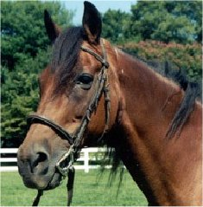
Emily
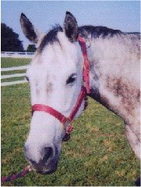
Midnight
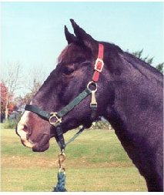
Sam
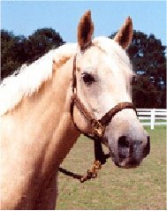
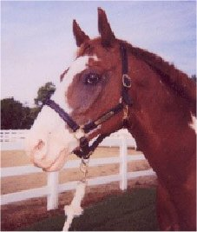
Spot

